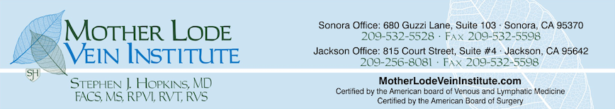

After Sclerotherapy Instructions

- Wear your compression stockings for 7 days total. For the 1st 24 hours after treatment, wear the stockings continuously (without removal of the stockings). Then, wear the stockings for 6 more days, during your waking hours
***It is recommend the spot compression (gauze rolls) with tape are removed the morning after treatment. However, the tape may irritate your skin; it is oaky to take them off if uncomfortable. Please make sure to wear your compression stockings***
- Avoid NSAIDs (Non-Steroidal Anti-Inflammatories) such as Aspirin, Advil (Ibuprofen), and Aleve (naproxen) for 48 hours after your sclerotherapy treatment
- Avoid hot baths and hot tubs for 48 hours; heat dilates the veins
- Avoid sun exposure, tanning beds, including self tanner for 7 to 10 days
- Avoid high-impact activities, such as running, and heavy lifting that causes straining for 7 to 10 days

Please remember that yours legs will look worse before they look better.
Any Questions or Concerns please call:
Sonora: 209-532-5528 Jackson: 209-256-8081

